**Expected Outcome:**

1. Brainstorm and identify the right metrics and frame proper questions for analysis. Your

analysis should help your:

a. Business team to understand the lead's journey and stages with scope for improvement

b. Business heads to understand their team performance

c. Managers to understand their target areas

2. In case you identify any outliers in the data set, make a note of them and exclude them from

your analysis.

3. Build the best suitable dashboard presenting your insights.

**Possible Metrics:**

1. Leads are generated from each source
2. Leads across different cities
3. Age distribution of leads
4. Gender distribution of leads
5. Percentage of Converted Leads
6. Average time taken for leads to move from one stage to another
7. Junior sales manager with highest conversion rate
8. Stages with the highest drop-off rate
9. Reasons stated by leads for not being interested in watching the demo Session
10. Reasons leads provide for not considering the product as a solution
11. Reasons leads gave for not converting

**Questions for each of the analysis topics:**

1.Lead's Journey and Stages with Scope for Improvement (1a):

a. What is the distribution of leads across different stages of the customer acquisition flow (lead, awareness, consideration, conversion)?

Sol: Out of 358 leads (leaving outliers) 64 got converted which is 17.88 % of total leads.

b. How much time, on average, do leads spend in each stage before progressing to the next one?

c. What are the main reasons leads drop out at each stage, and what can be done to reduce drop-offs?

Major Reason for not interested in Demo Class: ‘Wants offline Class’

Major Reason for not interested in Consideration: “Can’t Afford”

Major Reason for not interested in Converting: “Can’t Afford”

**Observation:** It is obvious from these that *Price of the course is not affordable to most of the leads*

d. Which lead generation sources (lead_gen_source) contribute the most to each stage of the customer acquisition flow?

Sol: Social Media contributes large portion of leads with 24.16% of all leads.

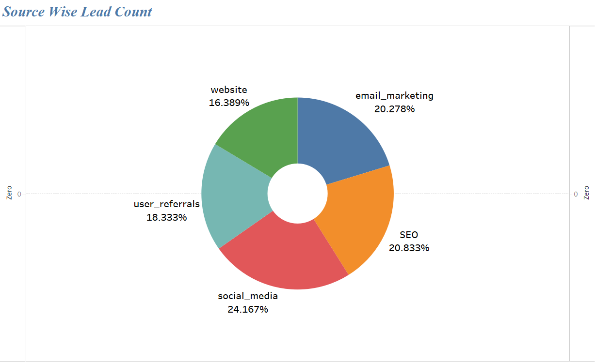

e. Is there any relationship between the leads' current education (current_education) and their progression through the stages?

**Observation**: From the visuals we can observe that most of ‘B.Tech’ and ‘looking for job’ have contributed to large portion of leads. But ‘B.Tech’ and ‘Degree’ have most lead to conversion ration.

f. What is Gender wise Lead count?

**2 Business Heads' Team Performance Understanding :**

a. How many leads are assigned to each junior sales manager (jnr_sm_id) in a cycle?

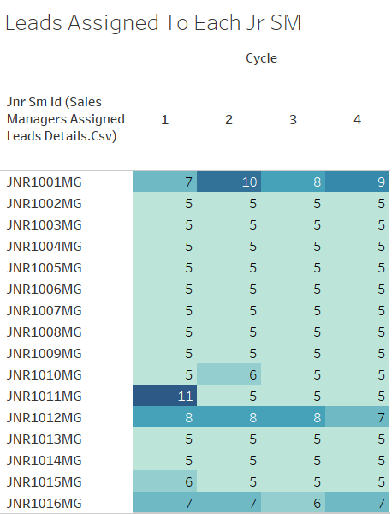

b. What is the average conversion rate of each junior sales manager from the lead stage to the conversion stage?

c. Which junior sales manager (jnr_sm_id) has the highest success rate (successful calls) in each stage of the customer acquisition flow?

d. How does the call status (successful/unsuccessful) vary across the stages, and are there any patterns to address?

3Managers' Target Areas Understanding (1c):

a. What are the main reasons given by leads for not being interested in watching the demo session (reasons_for_not_interested_in_demo)?

Sol: Main reason is ‘Wants offline class’

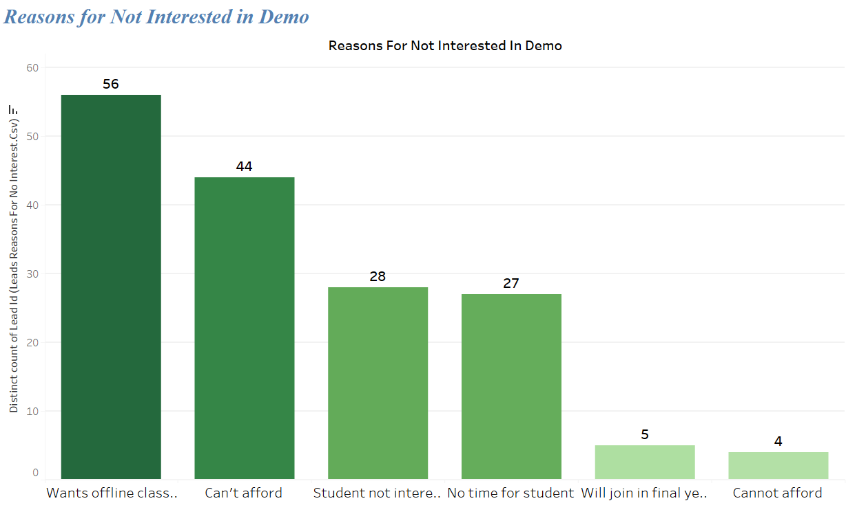

b. What are the key factors influencing leads' decisions at the consideration stage (reasons_for_not_interested_in_consideration)?

Sol: Main reason is “Can’t Afford”

c. What are the primary reasons leads provide for not converting (reasons_for_not_interested_in_conversion)?

Sol: Main reason is “Can’t Afford”

**Observation:** It can be observed that High Prices of the courses is the main reason for leads not getting moved from ‘awareness to consideration’ or ‘consideration to conversion’

d. Are there any specific cities or regions with higher drop-off rates, and how can we target these areas better?

OUTLIERS TREATMENT:

There are only two outliers found in Age column variable which are neglected in visualisations in TABLEAU by using ‘Exclude Option’.